**Module (JAVASCRIPT BASIC & DOM) – 4**

**(Basic logic Question)**

Q.1 What is JavaScript. How to use it?

Ans : JavaScript is a programming language used for creating interactive websites. You can use it by writing code within <script> tags in HTML or by linking external JavaScript files to your HTML document.

Q.2 How many type of Variable in JavaScript?

Ans : There are three types of variables in JavaScript:

var, let, and const.

Q.3 Define a Data Types in js?

Ans : Data types in JavaScript include numbers, strings, booleans, arrays, objects, null, and undefined.

Q.4 Write a mul Function Which will Work Properly When invoked With Following Syntax.

Ans :

function mul(a, b) {

return a * b;

}

Q.5 What the deference between undefined and undeclare in JavaScript?

Ans :

Undefined means a variable has been declared but not assigned a value, while undeclared means a variable has been used without being declared.

Q.6 Using console.log() print out the following statement: The quote 'There is no exercise better for the heart than reaching down and lifting people up.' by John Holmes teaches us to help one another. Using console.log() print out the following quote by Mother Teresa:

Ans : Code :-

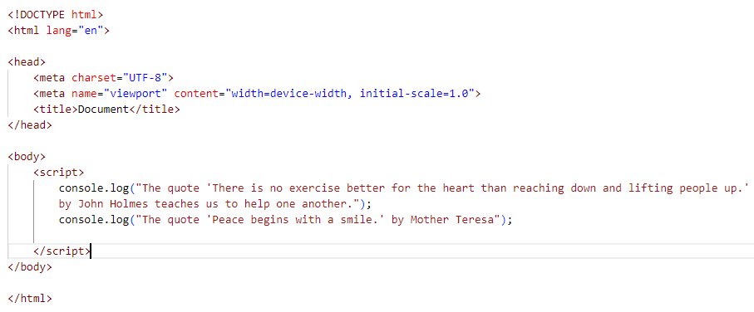

Output :

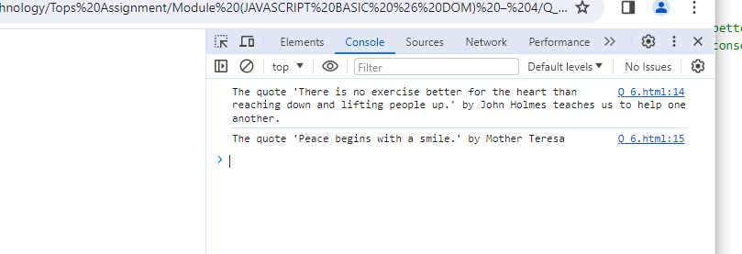

Q.7 Check if typeof '10' is exactly equal to 10. If not make it exactly equal?

Ans : code :-

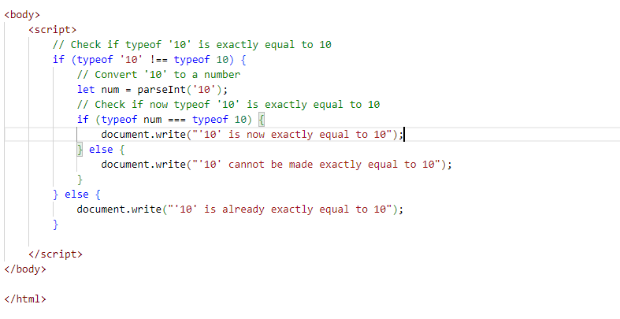

Output:

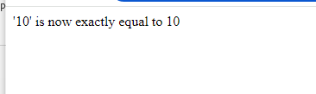

Q.8 Write a JavaScript Program to find the area of a triangle?

Ans : code :-

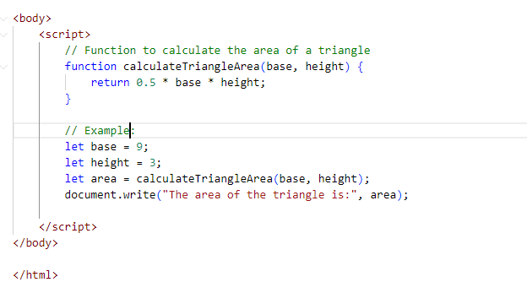

Output:

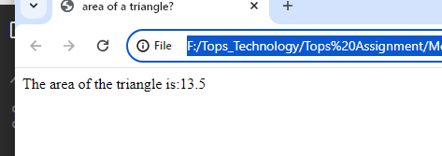

Q.9 Write a JavaScript program to calculate days left until next Christmas?

Ans : Code :

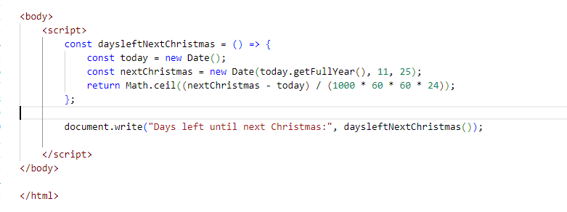

Output:

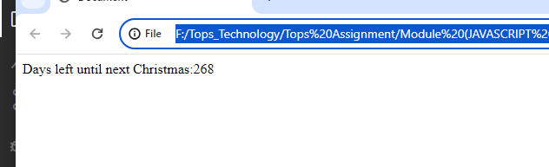

Q.10 What is Condition Statement?

Ans : There are multiple different types of conditionals in JavaScript including:

“If” statements: where if a condition is true it is used to specify execution for a block of code.

“Else” statements: where if the same condition is false it specifies the execution for a block of code.

“Else if” statements: this specifies a new test if the first condition is false.

Q.11 Find circumference of Rectangle formula: C = 4 * a ?

Ans :

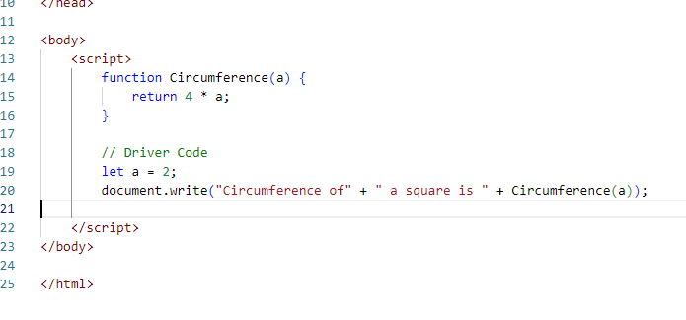

Output:

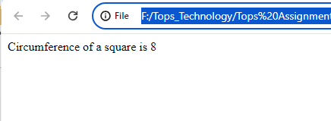

Q.12 WAP to convert years into days and days into years?

Ans :

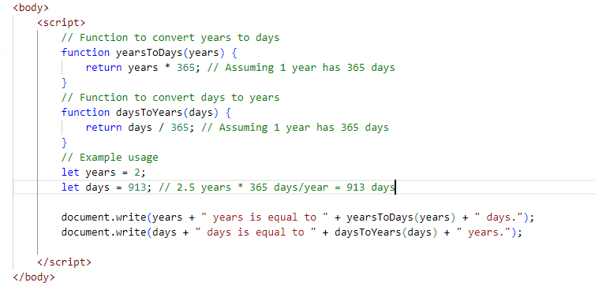

Output:

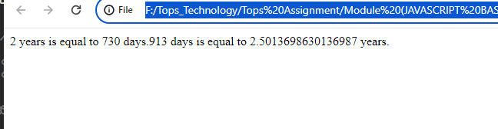

Q.13 Convert temperature Fahrenheit to Celsius? (Conditional logic Question)

Ans : 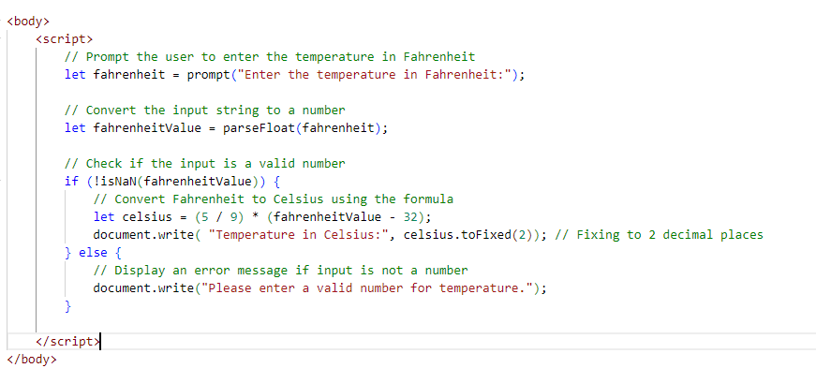

Output:

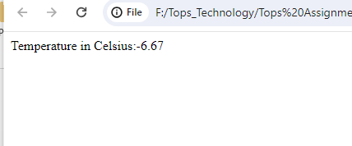

Q.14 Write a JavaScript exercise to get the extension of a filename.?

Ans :

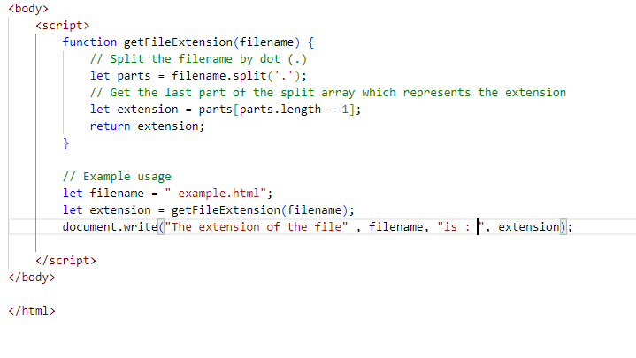

Output:

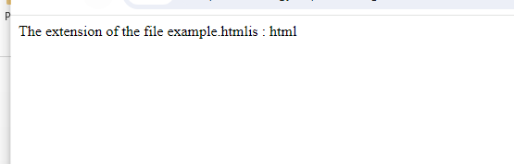

Q.15 What is the result of the expression (5 > 3 && 2 < 4)?

Ans :

The result of the expression (5 > 3 && 2 < 4) in JavaScript is true.

Here's why:

5 > 3 evaluates to true because 5 is greater than 3.

2 < 4 evaluates to true because 2 is less than 4.

In a logical AND operation (&&), both conditions must be true for the entire expression to be true. Since both 5 > 3 and 2 < 4 are true, the entire expression (5 > 3 && 2 < 4) evaluates to true.

Q.16 What is the result of the expression (true && 1 && "hello")?

Ans :

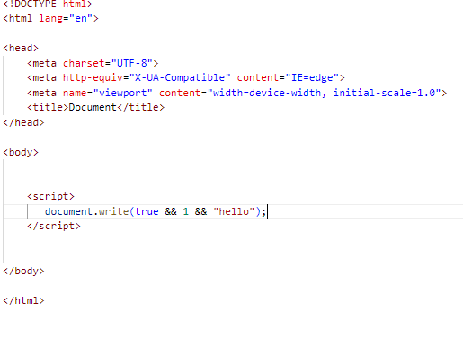

Output

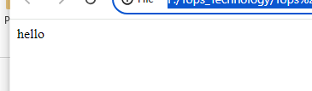

Q.17 What is the result of the expression true && false || false && true?

Ans :

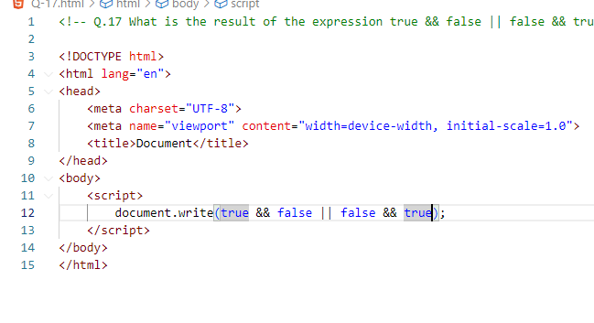

Output:

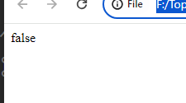

Q.18 What is a Loop and Switch Case in JavaScript define that ?

Ans :

* For loop: It repeats a block of code a specified number of times.

for (initialization; condition; increment/decrement) {

// code block to be executed

}

* while loop: It repeats a block of code while a specified condition is true.

while (condition) {

// code block to be executed

}

* do..while loop: It is similar to the while loop, but it always executes the block of code at least once before checking the condition.

do{

// code block to be executed

} while (condition);

* Switch case is another programming construct used for decision-making. It provides an alternative to the if-else statements when you have multiple conditions to evaluate.

switch (expression) {

case value1:

// code block to be executed if expression matches value1

break;

case value2:

// code block to be executed if expression matches value2

break;

// more cases can be added as needed

default:

// code block to be executed if expression doesn't match any case

}

Q.19 What is the use of is Nan function?

Ans : The isNaN() function in JavaScript is used to determine whether a value is NaN (Not-a-Number) or not. NaN is a special value representing an unrepresentable value as a number, typically arising from an operation that cannot produce a meaningful result

Here's how isNaN() works:

* If the argument passed to isNaN() is NaN or cannot be converted into a number, it returns true.
* If the argument is a valid number (including negative and positive infinity), or a numeric string that can be converted into a number, it returns false

Q.20 What is the difference between && and || in JavaScript?

Ans : In JavaScript, && and || are both logical operators used for combining conditions, but they operate differently:

* && returns true only if both operands are true.
* || returns true if at least one of the operands is true.

Q.21 What is the use of Void (0)?

Ans : In JavaScript, void(0) is a unary operator used to evaluate an expression and return undefined. It is typically used in conjunction with the href attribute of HTML <a> elements to create "pseudo-links" that don't navigate anywhere when clicked.

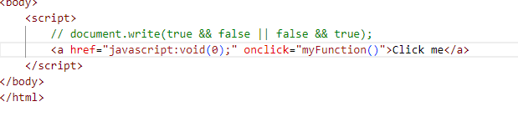

Q.22 Check Number Is Positive or Negative in JavaScript?

Ans The Math.sign() method retuns whether a number is negative, positive or zero.

* If the number is positive, this method returns 1.
* If the number is negative, it returns -1.
* If the number is zero, it returns 0.

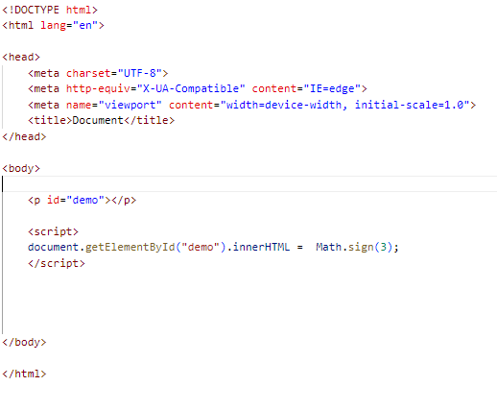

Output:



Q.23 Find the Character Is Vowel or Not ?

Ans :

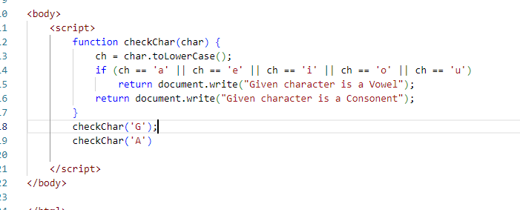

Output:

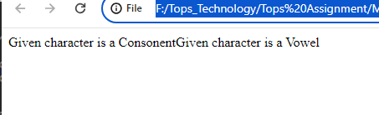

Q.24 Write to check whether a number is negative, positive or zero?

Ans :

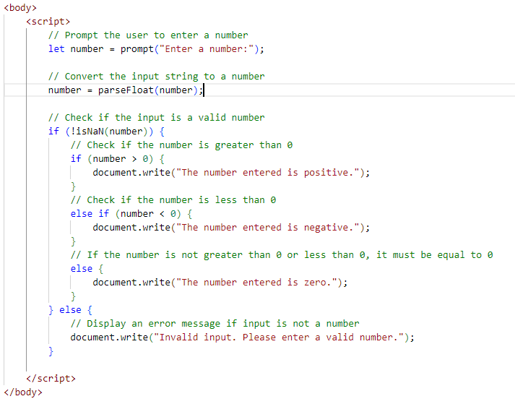

Output:

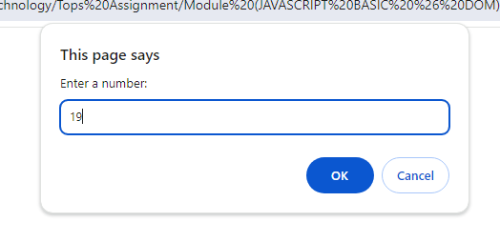

The number entered is positive.

Q.25 Write to find number is even or odd using ternary operator in JS?

Ans :

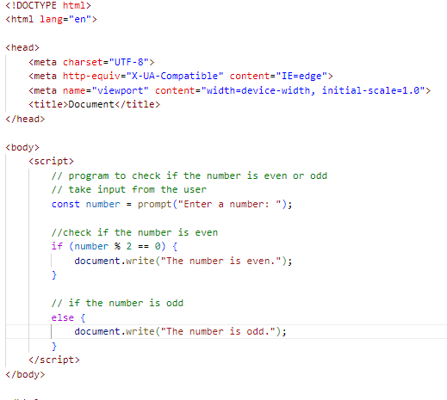

Output:





Q.26 Write find maximum number among 3 numbers using ternary operator in JS?

Ans :

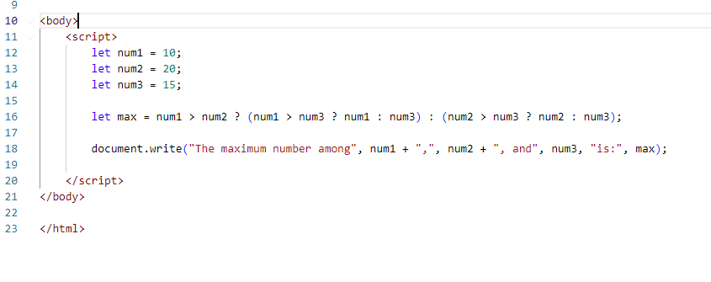

Output:

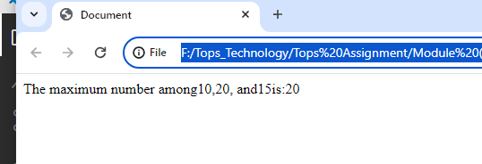

Q.27 Write to find minimum number among 3 numbers using ternary operator in JS?

Ans :

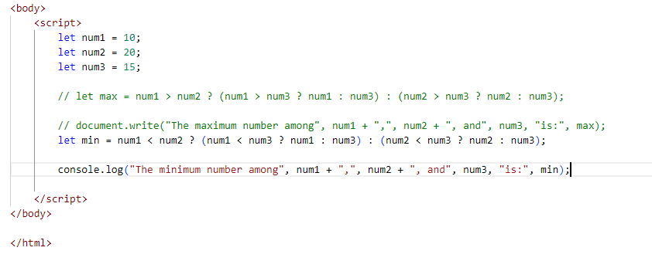

Output:

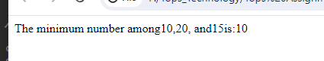

Q.28 Write to find the largest of three numbers in JS?

Ans :

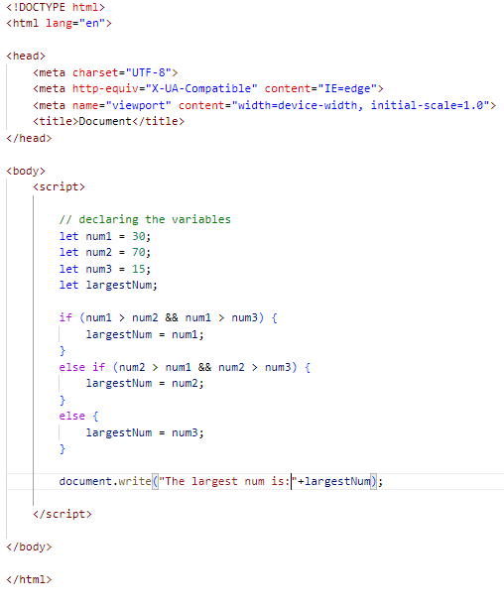

Output:



Q.29 Write to show

i. Monday to Sunday using switch case in JS?

Ans :

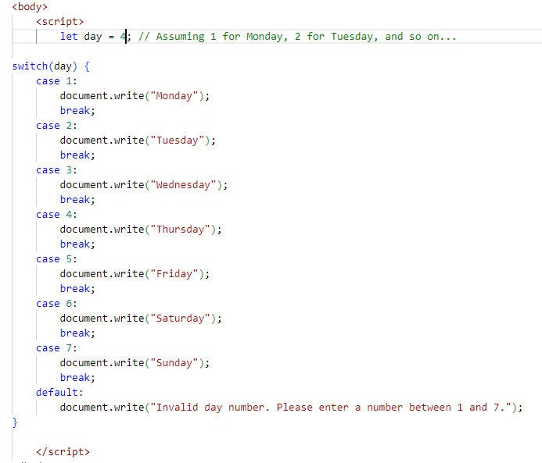

Output:

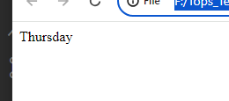

ii. Vowel or Consonant using switch case in JS?

Ans :

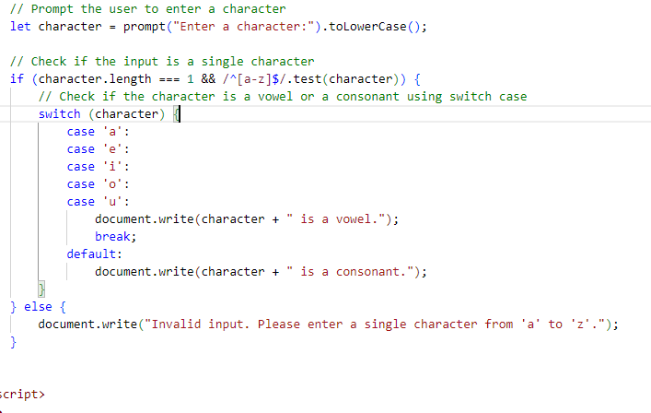

Output:

